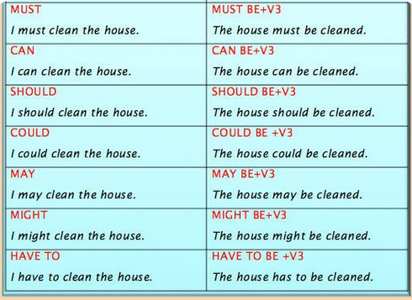

**VIDEO EXERCISE**

<https://www.grammarbank.com/passives-with-modals.html>